User Guide

**Control Plane, User Plane Gateways;**

**LTE EPC;**

**Installation Guide;**

**Troubleshooting Guide;**

**(Release 1.5)**

Contents

**Acronyms and Definitions** **4**

**Introduction** **5**

2.1 Background 5

2.2 Source Repository 6

2.2.1 ngic-rtc 6

2.2.2 oss_util 6

2.2.2 Freediameter 6

2.3 License 7

2.4 Specifications referred 7

2.5 Release updates 7

2.5.2 Release details. 7

2.5.2.1 New features 7

2.5.2.2 Important bug fixes and open items 9

**3 Deployment options** **12**

3.1 Combined SGW-PGW architecture 13

3.1.1 Deployment diagram 13

3.1.2 Configuration Settings 13

3.2 Split GW architecture 14

3.2.1 Deployment diagram 14

3.2.2 Configuration Settings 14

3.4 Decommission 15

**4 How To** **16**

4.1 Download 16

4.2 Installation of Control Plane and Data Plane 16

4.3 Build 20

4.4 Dependencies 22

4.5 Configure 22

4.5.1 Editing Control plane Configuration 24

4.5.2 Editing Date Plane Configuration 25

4.5.3 Editing gx app configuration 25

4.6 Launch 27

4.6.1 Run control plane, data plane and gx application 27

Control plane path :- ngic-rtc/cp 27

**5 Monitoring** **29**

5.1 CLI 29

5.2 Logging 29

5.2.1 c3pocli for logging 30

**6 Troubleshooting** **31**

6.1 How to bind PCI interface to dpdk driver 31

6.2 Set environment for Control Plane and Data Plane when referring the section 4.3 for compilation 32

6.3 Data not passing through data plane 32

6.4 Give Permission to Shell Script File 33

6.5 Memory Issue in Section 4.3 Control Plane build 33

**7. Backlog** **33**

**8. References** **34**

# 

# Acronyms and Definitions

**Table 1-1: Acronyms and Definitions**

|  |  |
| --- | --- |
| **Acronym** | **Definition** |
| LTE | Long-Term Evolution |
| 3GPP | 3rd Generation Partnership Project |
| SAE | System Architecture Evolution |
| EPC | Evolved Packet Core |
| OMEC | Open Mobile Evolved Core  is the first full-featured, scalable, high performance open source EPC. |
| ONF | Open Networking Foundation  is a non-profit operator led consortium driving transformation of network infrastructure and carrier business models. |
| UE | User Equipment |
| SGW-C | Serving Gateway – Control plane  routes and forwards control signal packets. |
| SGW-U | Serving Gateway – User plane  routes and forwards user data packets. |
| PGW-C | Packet Data Network Gateway – Control Plane  Processing of control signal messages for UEs. |
| PGW-U | Packet Data Network Gateway – User Plane  provides connectivity from the UE to external packet data networks. |
| SAEGW-C | System Architecture Evolution Gateway – Control Plane  is a combination of S-GW and P-GW control plane nodes. |
| SAEGW-U | System Architecture Evolution Gateway – User Plane  is a combination of S-GW and P-GW user plane nodes. |
| MME | Mobile Management Entity. |
| HSS | Home Subscriber Server. |
| DNS | Domain Name System. |
| DHCP | Domain Host Configuration Protocol. |
| PCRF | Policy and Charging Rules Function. |
| CDR | Charging Data Record |
| CTF | Charging Trigger Function |
| CDF | Charging Data Function |
| SGX | Software Guard Extensions  Intel’s protected environment that contains the code and data of a security-sensitive computation. |
| CUPS | Control and User Plane Separation of EPC nodes  Provides architecture enhancements for the separation of control and user messages functionality in EPC. |
| C3PO | Clean CUPS Core for Packet Optimization  is a code repository under OMEC-project.. |
| SDN | Software Defined Networking |
| NFV | Network functions virtualization |
| NGIC | Next Generation Infrastructure Core  is a code repository under OMEC-project |
| OSS | Operations Support System |
| CI-CD | Continuous integration and continuous delivery |
| PDN | Packet Data Network |
| CSID | Connection Set Identifier |
| APN | Access Point Name |
| FQ | Fully Qualified |
| CLI | Command Line Interface |
| BGP | Border Gateway Protocol |

# Introduction

This user guide is for LTE EPC Gateways developers and users as part of OMEC (Open Mobile Enhanced Core). This guide shall help users build, configure and deploy OMEC with the supported Gateway combinations. Guide also covers technical insights into architecture of the Gateway code, with open issues and backlog.

## 2.1 Background

OMEC project is open source LTE EPC development driven under Open Networking Foundation (ONF) consortium. Under OMEC there are a suite of projects working together to create EPC solutions. ‘ngic-rtc’ project provides Gateway components of the EPC.

Following diagram shows a set of components under EPC. ‘ngic-rtc’ project provides source code for SGW-C, PGW-C, SGW-U, PGW-U, SAEGW-C and SAEGW-U of these components.

This document is a user guide for ngic-rtc source code and Gateways combinations mentioned above. Throughout this document all gateway combinations (SGW-C, PGW-C, SGW-U, PGW-U, SAEGW-C and SAEGW-U) are commonly referred to as Gateways.

**Figure 2.1-1: EPC Architecture diagram**

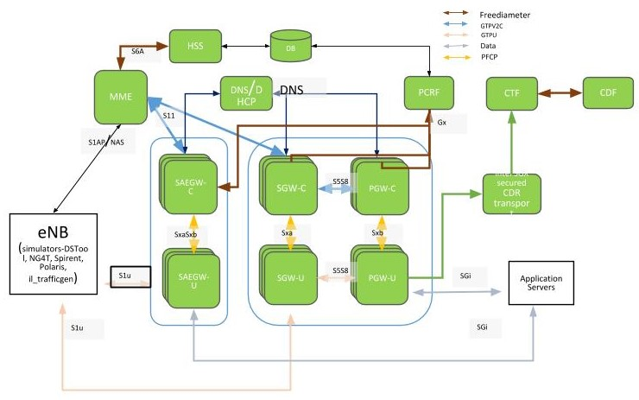

## 2.2 Source Repository

Following are the source code repositories relevant for Gateways development, deployment and testing.

### 2.2.1 ngic-rtc

Public repository for the Gateways is hosted at the following location and is maintained by OMEC TST members.

<TBD>

### 2.2.2 oss_util

Public repository for oss_util is at

<https://github.com/omec-project/oss-util>

### 2.2.2 Freediameter

Public repository for freediameter is at

<https://github.com/omec-project/freediameter>

## 

## 2.3 License

Complete source code is under [**Apache 2.0**](https://www.apache.org/licenses/LICENSE-2.0) license.

Any new addition to the code base has to follow the same license.

Any new open to be linked with must follow the license restriction and license contamination against Apache 2.0 has to be avoided.

Source code has gone through the following source control and license check process.

<License check process, contamination checks, blackduck etc.>

## 2.4 Specifications referred

3gpp specifications release 15 are referred for the project development.

Reference links to all specifications are mentioned in section 7.

## 2.5 Release updates

Latest release version is 1.5.

Release source code is available at following source control with the mentioned commit id.

<TBD>

Branch: delivery_1.5

Commit id: 786723f768e6d29abfb080d28ef043878017a636

### 2.5.2 Release details.

#### 2.5.2.1 New features

|  |  |
| --- | --- |
| **Feature** | **Reference** |
| UPF Selection by DNS | 23.003, 29.244, 23.401, 29.303 |
| PDN Initial Attach  EUTRAN UE Initial Detach | 23.401 - 5.3.2.1-1, 5.10.2  23.214 - 6.3.1.1 |
| Dedicated Bearer Activation | 23.214 - 6.3.1.7-1 |
| MME triggered SGW relocation | 23.214 - 6.3.1.2.2 |
| X2 handover SGW relocation | 23.214 - 6.3.1.2.2 |
| eNB F-TEIDu - X2 handover without SGW relocation | 23.401 - 5.5.1.1.2  23.214 - 6.3.1.3 |
| 3D State Machine with Procedure | 23.401, 23.214, 29.274, 29.244, 29.212, 29.213 |
| Sxa, Sxb, SxaSxb - Association, establishment, modification, session release. | PFCP support  29.244 |
| libGTPv2C Auto generated code on S11 and S5/S8 Interfaces | 29.274 |
| libpfcp Auto generated code integration on SxaSxb, Sxa, Sxb Interfaces | PFCP support  29.244 |
| CLI and statistics parameters | CLI to collect statistical information on various interfaces, protocols and operations. |
| API error with cause values | 29.274, 29.244 |
| Peer echo and timers | 29.274, 29.244  T3, N3 timers |
| Configuration file modification | Removed hard coded peer configurations for MME, SGWs and PGWs. Other configuration simplification. |

#### 2.5.2.2 Important bug fixes and open items

**Table 2.5.2.1-1: Bugs fixed in release**

|  |  |
| --- | --- |
| **Bug ID** | **Description** |
| 218 | SGWC created a new session with SGWU for retransmission of CSR. |
| 273 | SGX billing deployment fails |
| 325 | Over time, the resetsecs and upsecs statistics deviate by quite a bit without resetting the stats |
| 332 | [SAEGW_DP_Error] spgwu ngic_dataplane - Failed to remove GTPU header |
| 334 | Echo response from SAEGWU on S1U do not have Recovery: 0 |
| 335 | Support for Dedicated bearer in Handover scenarios |
| 337 | PFCP association setup happens even when TEIDRI is not provided in dp_config.cfg file |
| 340 | TEID RI value in DP configuration takes value which is out of range without any error handling |
| 341 | TEID range returned after CP restart is not correct |
| 342 | Error reporting in log files need to be consistent |
| 344 | Enable the automated deployment to take the configuration file as a parameter |
| 347 | Deployment fails filtering for NIC if it is not 10GbE |
| 349 | Add development tools (TMUX, screen) to development images |
| 357 | Split Gw multiple calls with multiple dedicated bearers data being lost in PGWU |
| 358 | No console notifications when peers are down |
| 374 | CLI-PGW - test ID #13 - missing PFCP Session Modification Reply |
| 386 | OMEC PGW sends Bearer-Identifier=35 in CCR-I and CCR-T |
| 389 | Need more detail in the Discarding packet due to gtp version is not supported messages |
| 395 | Create FAR Apply Action should be set to forward |
| 403 | During inter MME Tracking Area Update procedure without S-GW change- SGW-C during terminating the session, sends DSReponse to Old MME |
| 406 | The SPGWC process hangs |
| 415 | Losing packets on the downlink in combined GW test |
| 417 | OMEC creates new dedicated bearers instead of updating existing bearers |
| 419 | Executing a test multiple times without restarting the GW starts producing a repeating error on the control plane |
| 431 | No space left on device error when running a test case multiple times |

**Table  2.5.2.1-2: Open items or Backlog bugs**

|  |  |
| --- | --- |
| **Bug ID** | **Description** |
| 12 | CP - Received delete session on non-existent EBI & Dropping packet" |
| 14 | [VM Performance Degradation] - Unexcepted packet loss running NG40 test at higher PPS |
| 25 | Packet loss in uplink path |
| 44 | SPGW-C becomes unavailable |
| 45 | UE Requested Dedicated Bearer Resource Allocation fails |
| 48 | UE Requested Bearer Resource Modification with TFT change fails |
| 56 | Some CDR files are missing aftre load run (got 49 CDR for 25 UE sessions) |
| 73 | [Split Gateway] GTPV2C_CAUSE_CONTEXT_NOT_FOUND when using unexpected GTP Message ModifyBearer Request |
| 74 | [Split Gateway] GTPV2C_CAUSE_CONTEXT_NO when using Unexpected GTP Message DeleteSession Request |
| 94 | [Split-GW] Uplink Packet Loss |
| 96 | [Combined GW] DP Logging Errors During Performance Test |
| 97 | [Combined GW] Performance Test |
| 98 | [Split Gateway] Packet Loss during Performance Test |
| 137 | GW Alarms and Warnings |
| 260 | [Deployment] Need support to resume capability in case of failure |
| 316 | r13 TAC query is delayed too long after the eNB query fails |
| 319 | [Deployment] After killing the ngic process, DP itself restart service but manually need to start kni service. |
| 330 | Auto deployment does not check core_range to appropriate with hardware core mapping |
| 373 | Implementing Deployment using Remote Image repository |
| 379 | [Deployment] Automate SGX deployment |
| 380 | [Deployment] Secure deployment with integration with Vault(hashicorp) |
| 385 | OMEC doesn't send create_session_response for default bearer creation intermittently |
| 387 | OMEC doesnt respond to Delete-Session-Request with wrong bearer-id |
| 388 | pgwc and sgwc do not respond with CSResponse & cause-code for context replacement and additional pdn scanerios |
| 390 | OMEC does not respond to create session request with unknown apn |
| 391 | OMEC doesn't respond to echo req from MME intermittently |
| 393 | While testing E-UTRAN attach with same imsi and apn is present present on sgw-c, The PGW-C erroneously, throws error of default_eps_bearer_qos is missing |
| 394 | SGWC responds with Delete-Session-Request Cause : Context Not Found (64) for existing session still undergoing replacement |
| 402 | Combine the GW service and kni service on the DP nodes |
| 404 | no reply from PGWC when a diameter Protocol/Transient/Permanent error is returned by PCRF |
| 405 | No Response from SGW-C during MME initiated delete bearer procedure |
| 412 | SGWC does not send MBReq to PGWC during X2-based handover without Serving GW relocation and UE Time Zone changed |
| 414 | Deployment cleanup fails if VM is in shut off state at the target |
| 416 | SGWC does not send Modify-Bearer-Response(reject) response in the first attempt at times |
| 418 | S1-based handover is failing |
| 422 | OMEC does not support create session request during handovers with HO indication flags set during X2-based handover with S-GW change |
| 424 | SGW-C Does not respond to Release Access Bearers Request from MME |
| 425 | Implement Network time syncing in the VMs, and set the timezone to UTC |
| 433 | SGW doesn't respond to S11 delete-session-request after a path failure on S5 |
| 434 | PGWU does not initiate Sx heartbeats to PGWC |
| 435 | Consistently getting: Failure to allocate memory for upf list structure error with test case when creating somewhere near 80 sessions |
| 436 | OMEC returns Mandatory IE missing for E-UTRAN initial attach with (ipv6) |
| 437 | SGW-C Does not respond to Create Session Request when SGW-U is down |
| 438 | Longevity testing fails after a couple of hours with both the CP and DP aborting and restarting with the following errors |
| 439 | The SGWC gets into a state that can only be fixed by rebooting the VM |
| 440 | Entry not found for UE error in the DP |
| 441 | OMEC control plane does not retry PFCP Association Setup Request |
| 442 | OMEC user-plane does not respond with error-ind after path failure |

# 3 Deployment options

ngic-rtc can be configured to run in two types of deployment modes as mentioned below.

## 3.1 Combined SGW-PGW architecture

In this deployment architecture, a single instance of the control gateway works as a combination of SGW and PGW for the control plane, and a single instance of user gateway works as a combination of SGW and PGW for the user plane.

Architectural reference – 23.214 section 4.2.2.

### 3.1.1 Deployment diagram

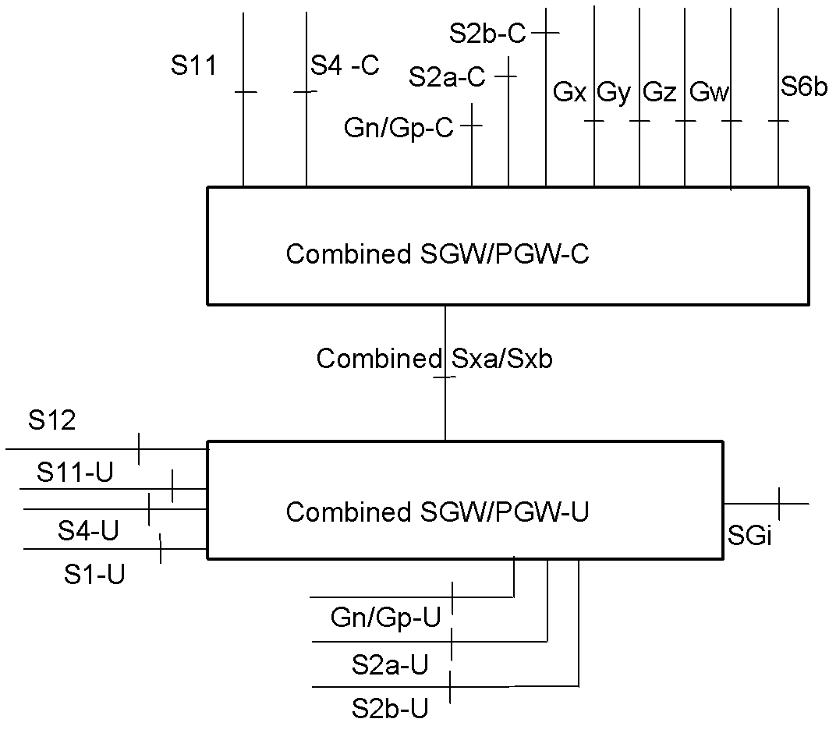

**Figure 3.1.1-1: Deployment diagram**

Diagram reference - specification 23.214, section 4.2.2

In section 2.1 of this document, under EPC architecture diagram combined SGW-PGW for control plane is shown as SAEGW-C. Throughout this document combined SGW-PGW control plane is referred as SAEGW-C.

In section 2.1 of this document, under EPC architecture diagram combined SGW-PGW for user plane is shown as SAEGW-U. Throughout this document combined SGW-PGW user plane is referred as SAEGW-U.

### 3.1.2 Configuration Settings

Following are the configuration runtime settings needed to run ngic-rtc as SAEGW-C.

CP_TYPE = 03

Following are the configuration settings needed to run ngic-rtc as SAEGW-U.

SPGW_CFG=03

For the details of the setup configuration refer section 4.

## 3.2 Split GW architecture

ngic-rtc can be deployed to run in CUPS architecture with four individual instances for SGW-C, PGW-C, SGW-U and PGW-U.

Architectural reference – 23.214 section 4.2.1

### 3.2.1 Deployment diagram

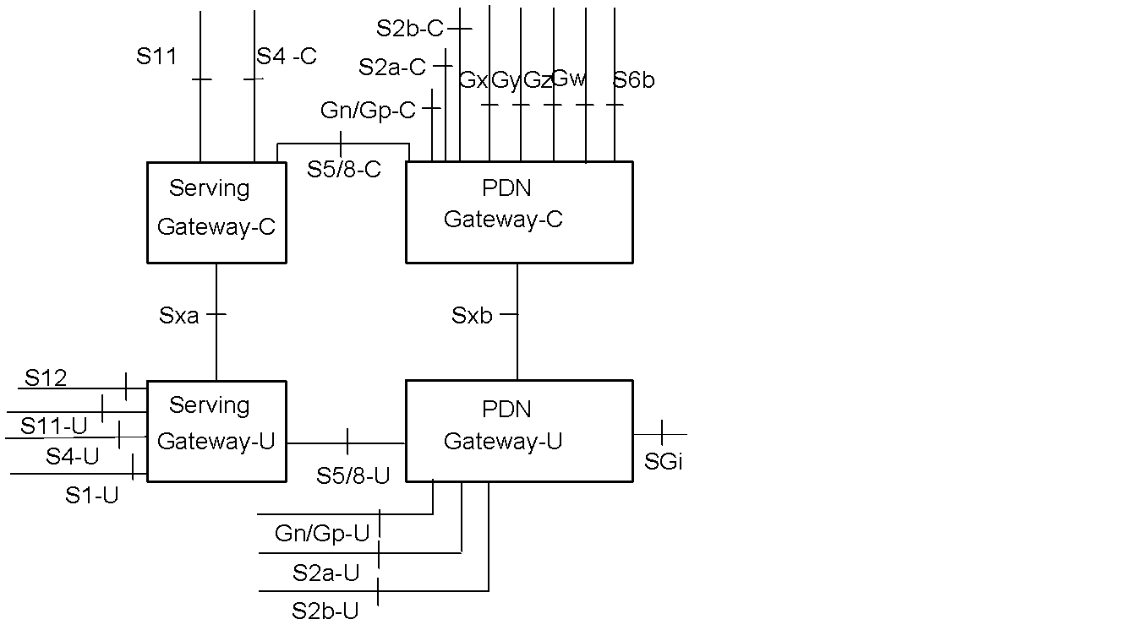

**Figure 3.2.1-1: Deployment diagram**

Diagram reference - specification 23.214, section 4.2.1

### 3.2.2 Configuration Settings

Following are the runtime configuration settings needed to run ngic-rtc as SGW-C.

CP_TYPE = 01

Following are the configuration settings needed to run ngic-rtc as PGW-C.

CP_TYPE = 02

Following are the configuration settings needed to run ngic-rtc as SGW-U.

SPGW_CFG=01

Following are the configuration settings needed to run ngic-rtc as PGW-U.

SPGW_CFG=02

Please refer to section 4 for the details of overall configuration.

## 3.4 Decommission

How to decommission a deployed system from setup.

# 4 How To

## 4.1 Download

Instruction to download from github.

> *git clone <Git repo URL>*

<Actual github path to be filled later on>

## 4.2 Installation of Control Plane and Data Plane

Run the install.sh script from ngic-folder

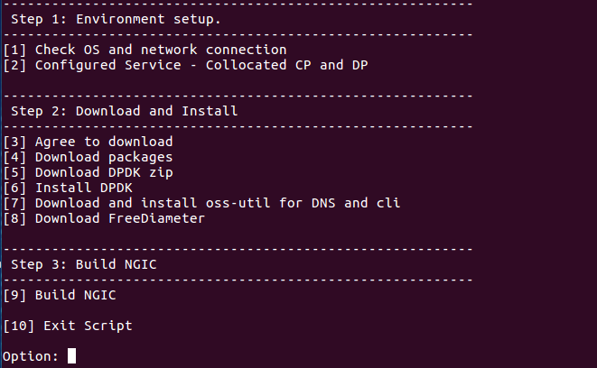

Figure 4.2a Install.sh Menu

### 4.2.1 Install Control Plane

Step 1:- Select Option 1 to know information about network connectivity and OS information

Step 2:- Select Option 2 to configure control plane

When click option 2 we will get new select menu

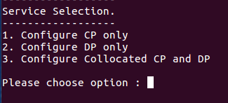

Figure 4.2.1a Service Selection Menu

Select option 1 for control plane

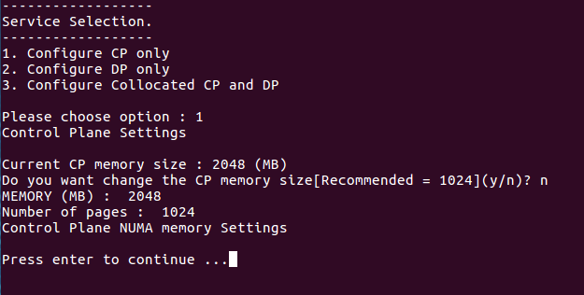

Figure 4.2.1b Control Plane Setting Selection

After this we will get new option to select memory if you want to change memory then select

OPTION ‘y’ to change the memory size else select OPTION ‘n’

Note:- Configure Collocated CP and DP is not supporting features till now.

Step 3:- Select Option 3 to make agreement to download dependent library or packages

Press y after selecting option 3

Step 4:- Select Option 4 to download packages.

Step 5:- Select Option 5 to Download DPDK zip file

Step 6:- Select Option 6 to install Data Plane Development Kit.

Step 7:- Select Option 7 will redirect you to oss-util and dns installation script.

Follow each step sequentially.

Step 8:- Select Option 8 to download the FreeDiameter open source library.

Step 9:- Select Option 9 to Build NGIC

This option builds and links all the libraries used to make the final binary.

### 4.2.2 Install Data Plane

Step 1:- Select Option 1 to know information about network connectivity and OS information

Step 2:- Select Option 2 to configure data plane server

When click option 2 we will get new select menu



Figure 4.2.2a Service Selection

Select option 2 for data plane

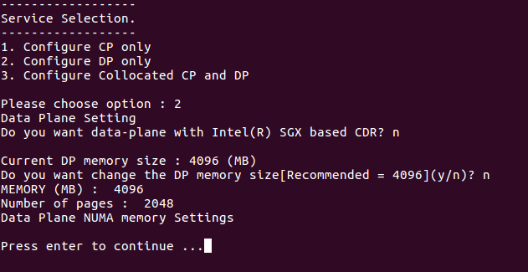

Figure 4.2.2b Data Plane Setting Selection

After selecting option 2 will get new select menu to select CDR, we need to press ‘n’

After this we will get new option to select memory if you want to change memory then select

OPTION ‘y’ to change the memory size else select OPTION ‘n’

Note:- Configure Collocated CP and DP is not supporting features till now.

Step 3:- Select Option 3 to make agreement to download dependent library or packages

Press y after selecting option 3

Step 4:- Select Option 4 to download packages.

Step 5:- Select Option 5 to Download DPDK zip file

Step 6:- Select Option 6 to install Data Plane Development Kit.

Step 7:- Select Option 7 to download hyperscan packages

Step 8:- Select Option 8 to Build NGIC

This option builds and links all the libraries used to make the final binary.

## 4.3 Build

These build options help users to build the code manually without ./install.sh script every time. Once setup is complete as section 4.2, for following code changes and build following steps can be followed.

1. **Control plane**

Path:- *cd ngic-rtc/cp*

Command:- *make clean; make;*

1. **Data plane**

Path:- *cd ngic-rtc/dp*

Command:- *make clean; make;*

1. **Oss-util**

Path:- *cd ngic-rtc/oss_adapter/c3po_oss/oss-util/*

Command:- *make clean; make; make install;*

Note:- After this step go to step 1

1. **Build libpfcp library**

Path:- *cd ngic-rtc/libpfcp*

Command:- *make clean; make;*

Note:- After this step go to step 1 or 2 according to the requirements of the server.

1. **Build libgtpv2c library**

Path:- *cd ngic-rtc/libgtpv2c*

Command:- *make clean; make;*

Note:- After this step go to step 1 or 2 according to the requirements of the server.

### 4.3.1 Runtime and Compile Time Flag List

1. DNS FLAG

Path:- *ngic-rtc/cp/Makefile*



4.3.1a

Function:- Disable DNS flag to discover Dataplane Plane Server statically.

Flag Type:- Compile Time

1. CP LOGGING FLAG

Path:- *ngic-rtc/config/cp.cfg*



4.3.1b

Function:- Activate Logging

Flag Type:- Run Time

1. GDB FLAG

Path:- *ngic-rtc/cp/Makefile*

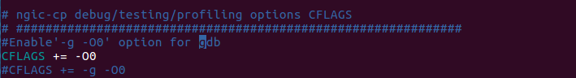

4.3.1c

Function:- uncomment the flag to enable debug mode and use ./run.sh debug command to activate debugging when run the Control Plane Server

Flag Type:- Compile Time

1. GX FLAG

Path:- *ngic-rtc/cp/Makefile*



4.3.1d

Function:- Remove gx functionality if comment the flag

Flag Type:- Compile Time

1. PERFORMANCE FLAG

Path:- *ngic-rtc/dp/Makefile*



4.3.1e

Function:- Remove Log Levels if uncomment the flag

Flag Type:- Compile Time

## 4.4 Dependencies

1) Latest **Ubuntu 16.04 LTS** should be installed, Latest ubuntu 16.04 LTS image can be downloaded from <https://www.ubuntu.com/download/alternative-downloads>

2) User account on the server with **root privileges**.

3) Peer components or their simulators are installed and configured. - MME. DNS. PCRF, eNB. SGi-AS.

4) List of packages which is installed by install.sh are:

* DPDK version 16.11.4
* build-essential
* linux-headers-generic
* git
* unzip
* libpcap-dev
* make
* hyperscan
* curl
* openssl-dev
* freediameter
* Pistache
* rapidjson
* spdlog
* cpp-driver
* c-ares
* and other library dependencies

## 4.5 Configure

Which files to use for runtime configuration

Which parameters to configure.

Sample configuration.

Interfaces configured here are:

**Table 5.1-1: Interfaces**

|  |  |
| --- | --- |
| **Interface** | **Description** |
| MGMT | mgmt network address space |
| DNS | dns network address space |
| S1MME | s1mme network address space |
| S6A | s6a network address space |
| DB | db network address space |
| S11 | network address space |
| SGWC_S5S8 | s5s8 control plane (sgw) network address space |
| PGWC_S5S8 | s5s8 control plane (pgw) network address space |
| FPCNB | fpc nb network address space |
| FPCSB | fpc sb network address space |
| S1U | s1u network address space |
| SGWU_S5S8 | s5s8 user plane (sgw) network address space |
| PGWU_S5S8 | s5s8 user plane (pgw) network address space |
| SGI | sgi network address space |
| CTF | ctf network address space |
| CDF | cdf network address space |

Sample or say default configuration defined for interfaces in ngic, is as given below. It leverages the networks or IPs defined in configuration.

[NETWORKS]

EX_MGMT="10.31.14.0/24"

MGMT="192.168.124.0/24"

S1MME="10.2.1.0/24"

S11="10.2.2.0/24"

DNS="192.168.122.0/24"

S6A="10.2.3.0/24"

DB="10.2.4.0/24"

S5S8_SGWC="10.2.5.0/24"

S5S8_SPGWC="10.2.5.0/24"

S5S8_PGWC="10.2.5.0/24"

S5S8_SGWU="10.2.6.0/24"

S5S8_PGWU="10.2.6.0/24"

FPCNB="10.2.7.0/24"

SXA="10.2.8.0/24"

SXB="10.2.8.0/24"

FPCSB="10.2.8.0/24"

GX="10.2.10.0/24"

S1U="11.9.1.0/24"

SGI="13.9.1.0/24"

CTF="10.214.93.0/24"

CDF="10.214.93.0/24"

### 4.5.1 Editing Control plane Configuration

This section shows the information about how to edit *ngic-rtc/config/cp.cfg* file for control plane.

|  |  |  |
| --- | --- | --- |
| Parameter | Description | Value |
| CP_TYPE | This value should be as per gateway. | SGWC = 01, PGWC = 02, SAEGWC = 03 |
| S11_IP | SGWC S11 interface ip | IPV4 |
| S11_PORT | GTPV2 Port number | 2123 |
| S5S8_IP | SGWC s5s8 interface ip if SGW and PGWC s5s8 interface ip if PGW | IPV4 |
| S5S8_PORT | GTPV2 Port number | 2123 |
| PFCP_IP | SX interface ip of SGWC/SAEGWC | IPV4 |
| PFCP_PORT | PFCP protocol port | 8805 |
| MME_S11_IP | MME S11 interface ip | IPV4 |
| MME_S11_PORT | GTPV2 Port number | 2123 |
| UPF_PFCP_IP | Need to select data plane path when DNS is disable | IPV4 |
| UPF_PFCP_PORT | PFCP protocol port number | 8805 |
| CP_LOGGER | Used to activate logging | 0 or 1 |
| APN_CONFIG | Add apn Configuration value | apn |
| APP nameserver | Ip address of app server for DNS query | IPV4 |
| OPS nameserver | Ip address of ops server for tac and apn based query | IPV4 |
| IP_POOL_CONFIG | Add ip pool configuration for UE ip allocation. | IPV4 |

### 4.5.2 Editing Date Plane Configuration

This section shows the information about how to edit config files to run data plane.

1. Edit *ngic-rtc/config/dp_config.cfg* file

* Change the value of SPGW_CFG as per gateway.
* Change the value of ip, mac address, and port according to the configured interface on the machine for flow of data packets.

1. Edit *ngic-rtc/config/interface.cfg* file

* Change the value of dp_comm_ip parameter and cp_comm_ip parameter in ngic-*rtc/config/interface.cfg*

Note:- Need to bind data plane interfaces to dpdk driver before running the server.

<https://doc.dpdk.org/guides/tools/devbind.html>

### 4.5.3 Editing gx app configuration

This section shows the information about how to edit config files to run gx applications.

1. Edit the *gx.conf* file available at path:

*ngic-rtc/cp/gx_app/gx.conf*

Hostname: pgwc6 (Modify in Identity,TLS_Cred)

Realm: test3gpp.net (Identity, Realm)

As shown in Figure 4.5.3a below:

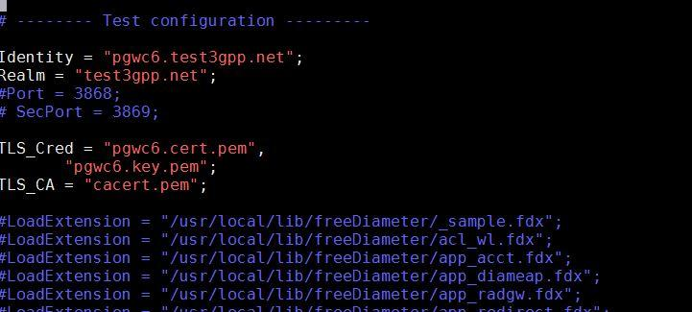

Figure 4.5.3a gx.conf File

2. Modify the PCRF <Hostname>.<Realm> {connectTo= “PCRF IPV4 ”; NO_TLS,port = 3868}

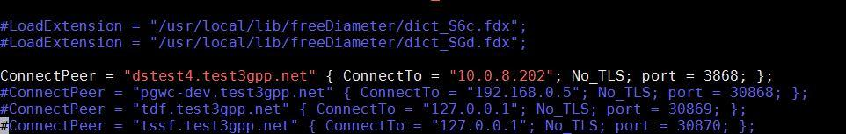

Figure 4.5.3b gx.conf File

3. Generate the certificate file with command

*./make_certs.sh <hostname> <Realm>*

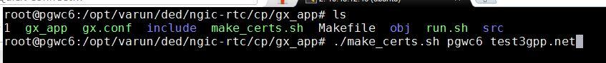

Figure 4.5.3c Certificate Make Command

and its output will be :

*<Hostname>.cert.pem*

*<Hostname>.csr.pem*

*<Hostname>.key.pem*

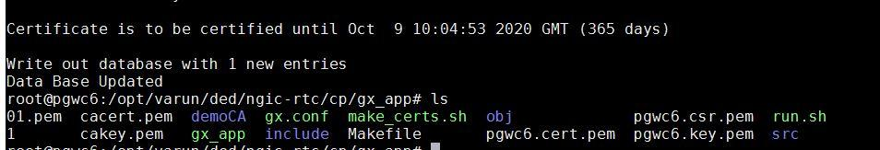

Figure 4.5.3d Certificate Make Console Result

More detail information can be read from the below mentioned link:

<http://www.freediameter.net/trac/wiki/Configuration>

## 4.6 Launch

Prerequisite for running the following component is that EPC setup is up and running with DNS and PCRF as per configured in Gateway configuration files.

### 4.6.1 Run control plane, data plane and gx application

### Control plane path:- *ngic-rtc/cp*

1. Data plane path:- *ngic-rtc/dp*
2. Gx app path:- *ngic-rtc/cp/gx_app*

Run the *run.sh* script in the above mentioned path to run all servers.

4.6.2 Use Kni script to up the data plane path

Kni script path: - *ngic-rtc/kni_ifcfg*

1. *kni-S1Udevcfg.sh* is used to up the S1U interface data plane path for data packets.
2. *kni-S5S8devcfg.sh* is used to up the S5S8 interface in case of split gateway for flow of data packets.
3. *kni-SGIdevcfg.sh* is used to up the SGI interface data plane path for data packets.

# 5 Monitoring

SGWC, PGWC, and SAEGWC can be controlled, monitored and tuned through the command line. Appropriate logs are available for all and view of which is available through right commands. The section below provides details of the same.

## 5.1 CLI

Run the cp or dp as SAEGW-C/U,SGWC/U,PGWC/U using ./run.sh script in ngic-rtc folder.

Use readme file to set c3pocli environment *ngic-rtc/oss_adapter/c3po_oss/oss-util/cli/README.TXT*

Once CLI is setup with above steps, we can leverage it with command - ***c3pocli***

c3pocli command on command prompt can be used with several arguments as illustrated below:

1. c3pocli[http://127.0.0.1:12997](http://127.0.0.1:12997/) stats describe-stats-live

Gives live statistics of all peers in JSON format.

1. c3pocli http://127.0.0.1:12997 stats describe-stats-all

It will show all messages on each interface.

## 5.2 Logging

Logs are maintained in the following 3 files under *ngic-rtc/cp/logs* folder.

1. *cp.log* - Console messages are logged into this file.



Figure 5.2a cp.log file

2. *cp_stat.log* - Stats after each 5 sec (stat frequency set to 5 sec by default) are logged into this file in JSON object format.

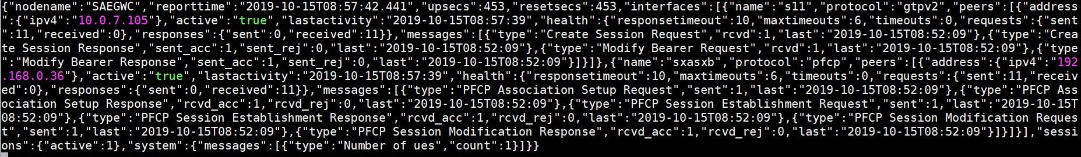

Figure 5.2b cp_stat.log File

3. *cp_sys.log* - Only log level with major, minor & critical will be logged into this file.



Figure 5.2c cp_sys.log File

### 5.2.1 c3pocli for logging

1. *c3pocli* [*http://127.0.0.1:12997*](http://127.0.0.1:12997/) *logger describe-logger*



Figure 5.2.1a

This command returns a JSON string with the current loggers and their log levels

1. *c3pocli* [*http://127.0.0.1:12997*](http://127.0.0.1:12997/) *logger set-logger-level -n system -l 0*

This command updates the log level for the specified logger name.



Figure 5.2.1b

Valid log levels are: Trace=0, Debug=1, Info=2, major=3, minor = 4 and critical=5

1. *c3pocli http://127.0.0.1:12997 stats set-stats-logging -n all*



Figure 5.2.1c

This command updates the stats logging mode.In “all” level, Show all messages on each interface. Interfaces appear based on Gateway type. Ex. If SGWC then “S11,S5S8 and Sxa” interface show By Default, “suppress” mode is configured.

1. *c3pocli http://127.0.0.1:12997 stats set-stats-logging -n suppress*

This command updates the stats logging mode to suppress mode for save data in file.In “suppress”mode, we show messages which arrive on the interface(S11, S5S8 etc).

1. *c3pocli* [*http://127.0.0.1:12997*](http://127.0.0.1:12997/statfreq) *stats describe-stats-frequency*

This commands shows the information about frequency of writing content

in the cp_stat.log file.

1. *c3pocli* [*http://127.0.0.1:12997*](http://127.0.0.1:12997/) *stats set-stats-frequency -f 2000*

Sets the statistics frequency, value is in milliseconds.

# 6 Troubleshooting

## 6.1 How to bind PCI interface to dpdk driver

Bind the S1u/Sgi port to DPDK drivers

1. Command to get PCI address is:

|  |
| --- |
| root@spgwu:/opt/ngic-rtc/dpdk/usertools# lshw -c network -businfo  Bus info Device Class Description  ========================================================  pci@0000:00:03.0 ens3 network Virtio network device  pci@0000:00:04.0 ens4 network Virtio network device  pci@0000:00:08.0 ens5 network 82599ES 10-Gigabit SFI/SFP+ Network Connection  pci@0000:00:09.0 ens6 network 82599ES 10-Gigabit SFI/SFP+ Network Connection  ... |

1. Bind the port using the PCI id

|  |
| --- |
| cd /opt/ngic-rtc/dpdk/usertools/  ./dpdk-devbind.py -b igb_uio 00:08.0 |

1. Lists ports

|  |
| --- |
| root@spgwu:/opt/ngic-rtc/dpdk/usertools# ./dpdk-devbind.py --status  Network devices using **DPDK-compatible driver**  ============================================  0000:00:08.0 '82599ES 10-Gigabit SFI/SFP+ Network Connection 10fb' drv=igb_uio unused=ixgbe  Network devices using kernel driver  ===================================  0000:00:03.0 'Virtio network device 1000' if=ens3 drv=virtio-pci unused=igb_uio *Active*  0000:00:04.0 'Virtio network device 1000' if=ens4 drv=virtio-pci unused=igb_uio *Active*  0000:00:09.0 '82599ES 10-Gigabit SFI/SFP+ Network Connection 10fb' if=ens6 drv= ixgbe unused=igb_uio  … |

## 6.2 Set environment for Control Plane and Data Plane when referring the section 4.3 for compilation

Path: - *cd ngic-rtc/*

Command:- *source setenv.sh*

## 6.3 Data not passing through data plane

1. Check PGWU/SAEGWU/SGWU *ngic-rtc/config/dp_config.cfg* configuration file.
2. Check the **MAC address** and **IP Configuration**

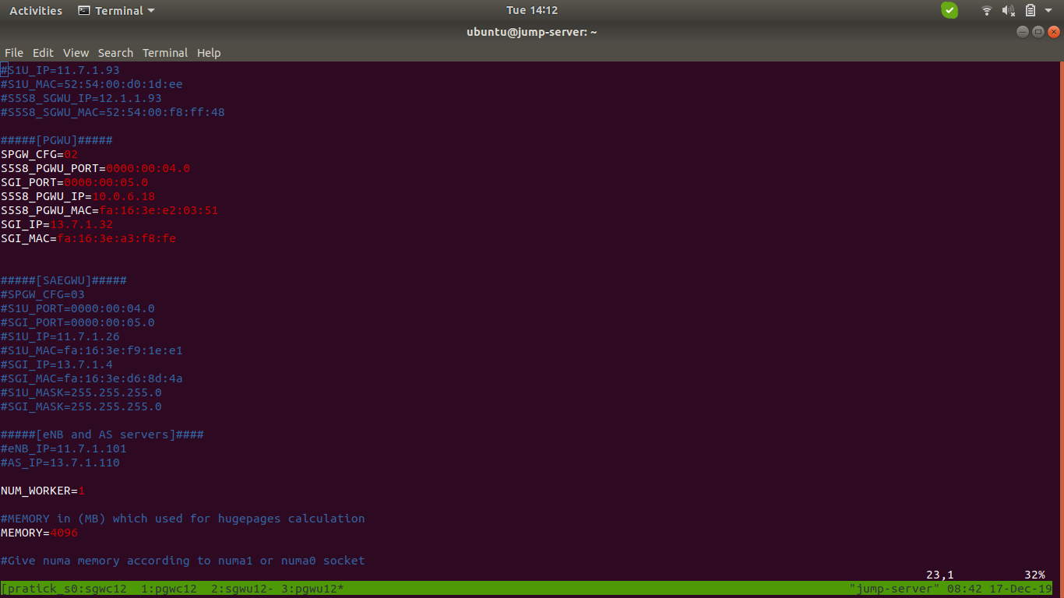

Figure 6.3a dp_config.cfg File

## 6.4 Give Permission to Shell Script File

command:- *chmod +x < filename >*

## 6.5 Memory Issue in Section 4.3 Control Plane build

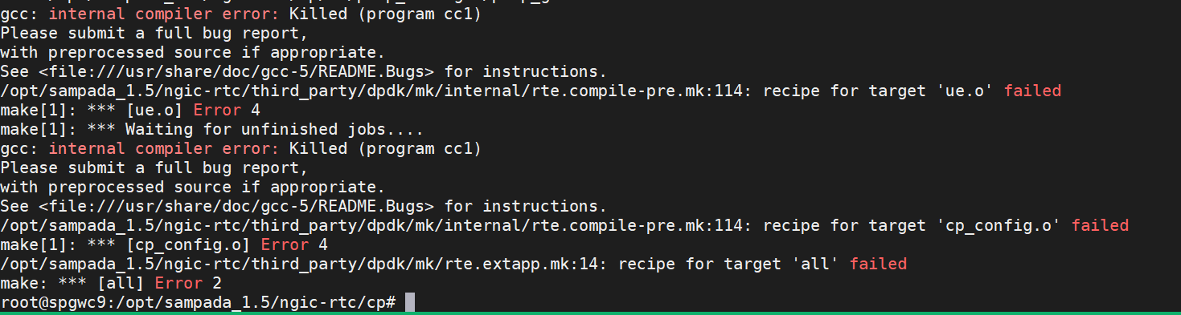

Figure 6.5a Memory Issue

Step 1:- Go to *ngic-rtc/ path*

Step 2:- Run the source *setenv.sh* Command

Step 3:- *make -j5 build-cp*

# 7. Backlog

Following is the feature backlog for this release. Most of the features mentioned in the backlog are in the development plan for the upcoming release.

|  |  |
| --- | --- |
| **Feature** | **Details** |
| IPv6 support | IPv6 and IPv4v6 dual mode support |
| Gx events |  |
| CDR generation | Usage records information passing to control plane as per specification <> |
| Lawful Interception |  |
| Restoration procedure | Handling of Partial or complete failure, recovery as per specification 23.007 |
| 23.401 flows | S1 handover  X2 Handover  S1 Handover  TAU update with/without SGW change  Secondary RAT usage reporting  ERAB Modification  Bearer Modification/Deactivation  Connection suspend/resume |
| Multiple PDN connections support |  |
| Diameter messages | CCR-U, CCA-U |
| Handover scenarios |  |
| SAGEGW to PGW Promotion and Demotion for a PDN connection. |  |

# 8. References

1. 3GPP specifications release 15.
   1. 23.401
   2. 23.214
   3. 23.272
   4. 23.003
   5. 23.007
   6. 29.212
   7. 29.244
   8. 29.303
   9. 29.212
   10. 29.213
2. Open Networking Foundation https://www.opennetworking.org/